WinExec
lpCmdLine
- Pointer to a null-terminated character string that contains the command line( file name plus optional parameters) for the app to be executed.
- Search priority
- The exe name is treated as the first white space-delimited string
- Malicious opportunity
- “\” xxx\”yy”

nCmdShow:
This param is ignored the first time an app calls ShowWindow, if the program that launched the app provides a STARTUPINFO structure.
Otherwise, the first time ShowWindow is called, the value should be the value obtained by the WinMain function in its nCmdShow parameter.

The WinExec function returns when the started process calls the GetMessage function or a time-out limit is reached.
To avoiding for the time out delay, call the GetMessage function as soon as possible in any process started by a call to WinExec.

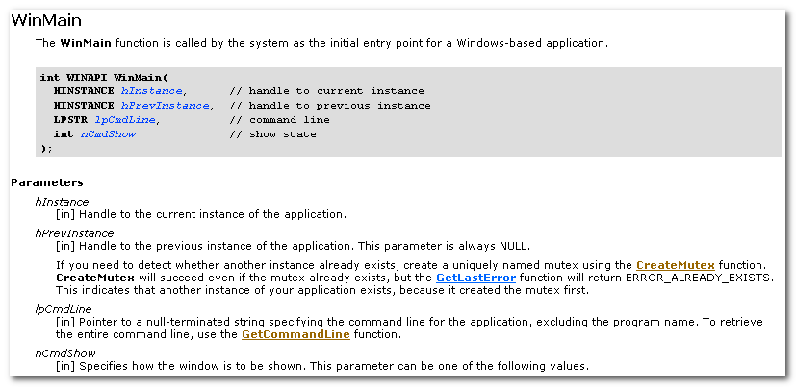
WinMain function is called by the system as the initial entry point fro a Windows-based app.

ShellExecute
The Shell Namespace
mk:@MSITStore:E:\Program\MSDN\2001OCT\1033\Shellcc.chm::/platform/Shell/Shell_basics/Namespace.htm#ids

The Shell namespace organizes the FS and other objects managed by the Shell into a single tree-structured hierarchy.
- Folders , files
- Net printer
- Net pc
- Control Panel apps
- Recycle Bin

Virtual Objects do not involve physical storage at all.

Item ID, is the functional equivalent of a file or folder name.
SHITEMID

typedef struct _SHITEMID {
USHORT cb;
BYTE abID[1];
} SHITEMID, * LPSHITEMID;

Apps should simply treat them as a token that identifies an object in a particular folder.
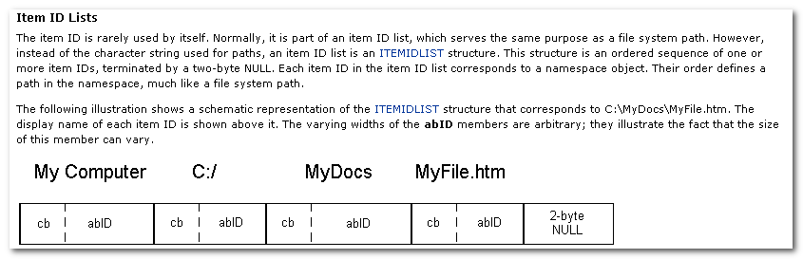

CreateProcess
lpApplicationName:
In the case of a partial name, the function uses the current drive and current directory to complete the specification. The function will not use the search path.

The lpApplicationName parameter can be NULL. In that case, the module name must be the first white space-delimited token in the lpCommandLine string.
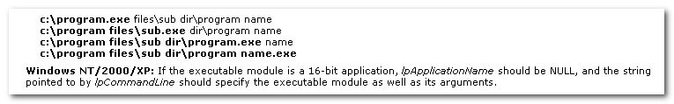

It is a common practice to repeat the module name as the first token in the command line.

The system adds a null character to the command line string to separate the file name from the arguments. This divides the original string into two strings for internal processing.

bInheritHandles
Indicates whether the new process inherits handles from the calling process.
If TRUE, each inheritable open handle in the calling process is inherited by the new process.
Inherited handles have the same value and access privileges as the original handles.

lpProcessAttributes/lpThreadAttributes
Pointer to a SECURITY_ATTRIBUTES structure that determines whether the returned handle can be inherited by child processes.

所以，继承是由两部分共同决定的：
- 各HANDLE自身，在各HANDLE产生、获得时（如OpenProcess, CreateEvent)，决定自身是否愿意被继承。
- 所在进程新建子进程时，决定是否允许该进程内的HANDLE被继承。

只有当这两部分都为TRUE， 都允许被继承时，才能被继承，缺一不可。

Note that an ANSI environment block is terminated by two zero bytes:
- one for the last string,
- One more to terminate the block.

A Unicode environment block is terminated by 4 zero bytes:
- two for the last string
- Two more to terminate the block

PROCESS_INFORMATION:
A handle to the newly created process. The handle is used to specify the process in all functions that perform operations on the process object.

A handle to the primary thread of the newly created process. The handle is used to specify the thread in all functions that perform operations on the thread object.

A global process identifier that can be used to identify a process.
A global thread identifier that can be used to identify a thread.

STARTUPINFO
Specify main window properties if a new window is created for the new process.

For GUI processes, this info affects the first window created by the CreateWindow function and shown by the ShowWindow function.

For console processes, this info affects the console window if a new console is created for the process.

The calling thread can use the WaitForInputIdle function to wait until the new process has finished its initialization and is waiting for user input with no input pending.
This can be useful for synchronization between parent and child processes, bkz CreateProcess returns without waiting for the new process to finish its initialization.

The preferred way to shut down a process is by using the ExitProcess function, because this function sends notification of approaching termination to all DLLs attached to the process.
Other means of shutting down a process do not notify the attached DLLs.

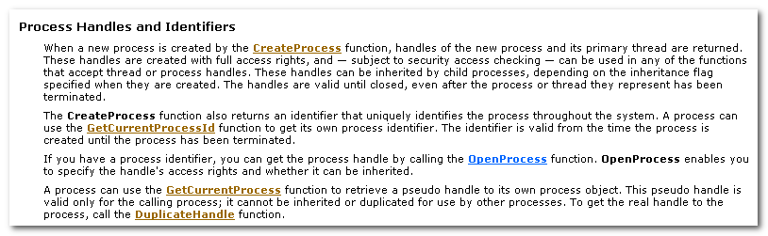

3.1 继承
继承是由两部分共同决定的：
- 各HANDLE自身，在各HANDLE产生、获得时（如OpenProcess, CreateEvent)，决定自身是否愿意被继承。
- 所在进程新建子进程时，决定是否允许该进程内的HANDLE被继承。

只有当这两部分都为TRUE， 都允许被继承时，才能被继承，缺一不可。
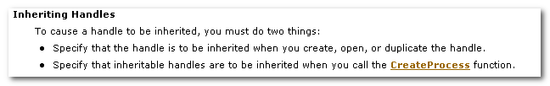

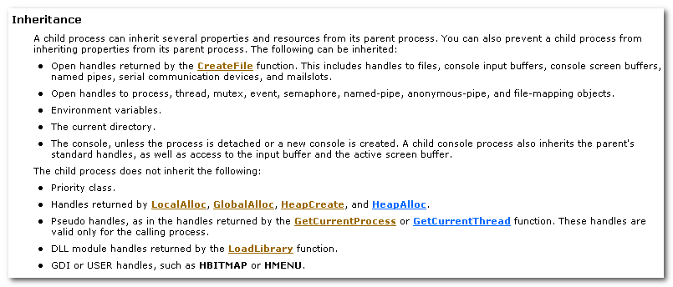

An inherited handle refers to the same object in the child process as it does in the parent process.
It also has the same value and access privileges.

A child process inherits the current directory of its parent process by default.

By default, a child process inherits the environment variables of its parent process.

3.2进程间通信(Interprocess Communication)
To use a handle, the child process must retrieve the handle value and “know” the object to which it refers.
Usually, the parent process communicate this info to the child process through its command line, environment block, or some form of interprocess communication.

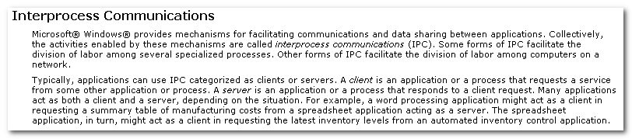
Typically, applications can use IPC categorized as clients or servers.
A client is an application or a process that requests a service from some other application or process.
A server is an application or a process that responds to a client request.
Many apps acts as both a client and a server.
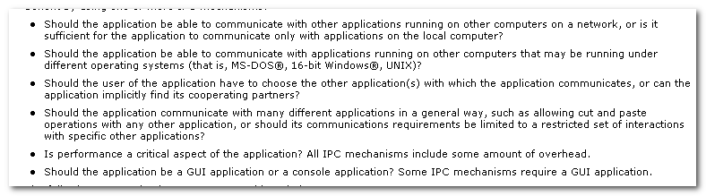
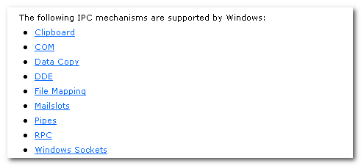

Terminating a Process
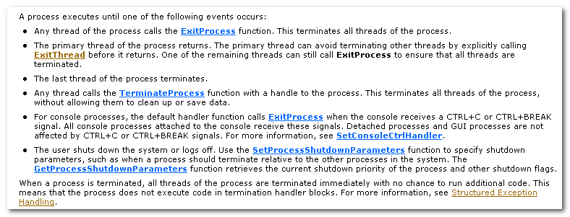
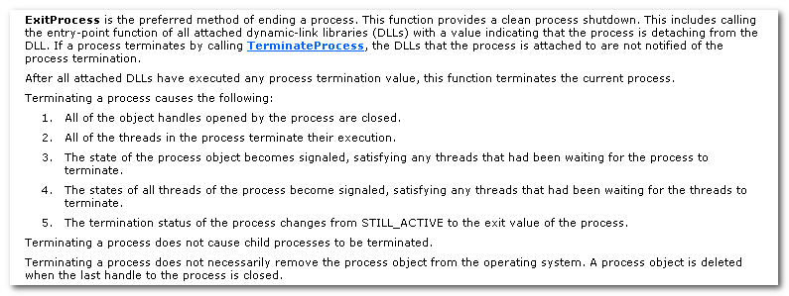
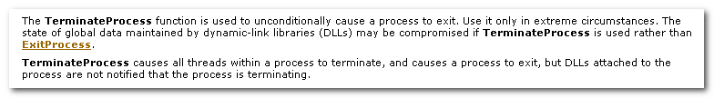

窗口、进程相关
切入点：
GetWindowThreadProcessId
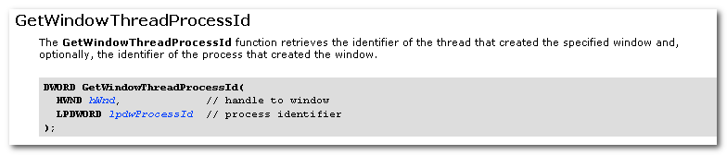

模块、进程相关
切入点：
GetModuleFileName,
GetModuleHandle
